**Day 21_task**

Create a S3 bucket, with no public access and upload files to the bucket & view the logs for the uploaded files. Launch two ec2-instances and connect it to a application load balancer, where the output traffic from the server must be an load balancer IP address

**Step 1: Create an S3 bucket**

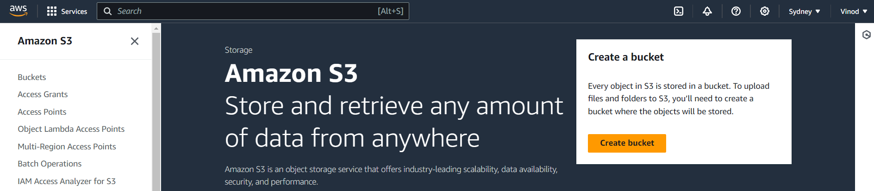

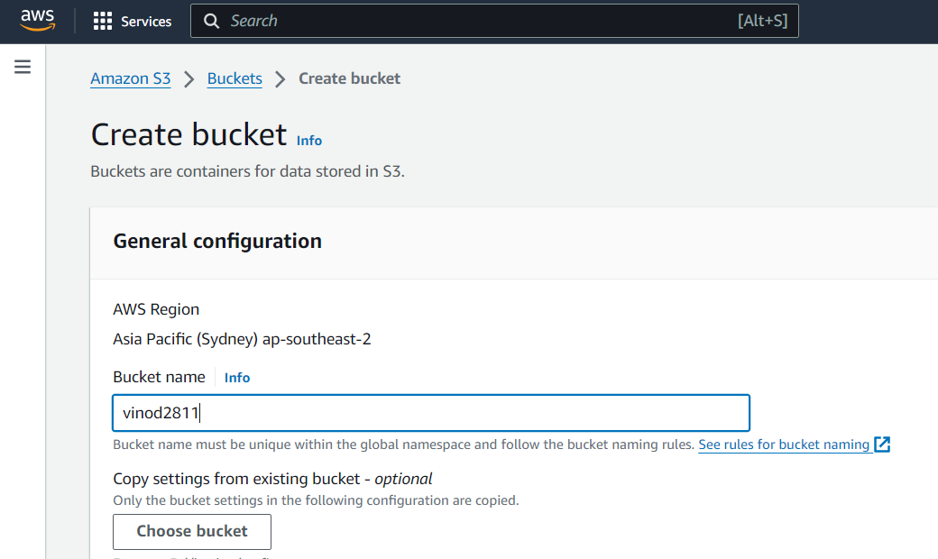

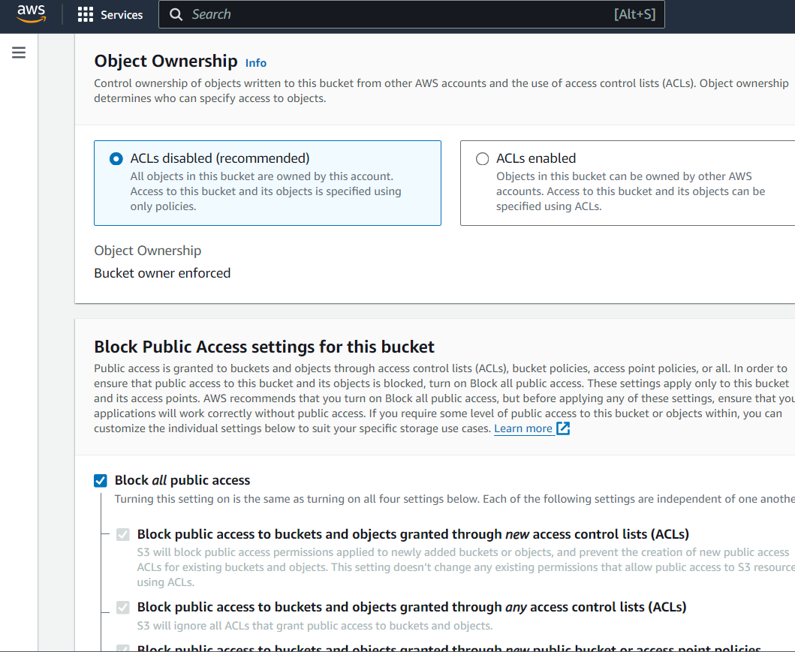

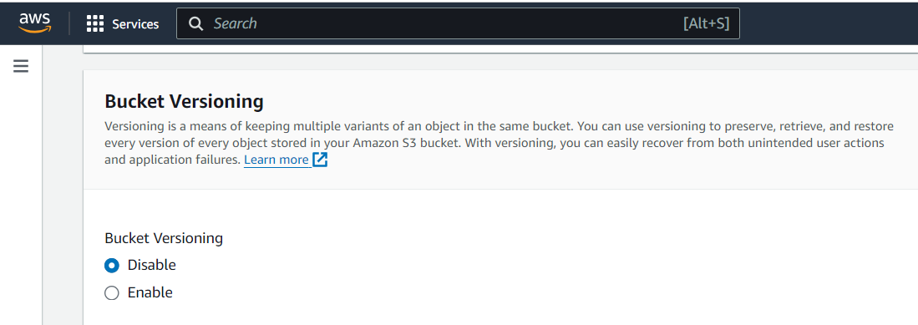

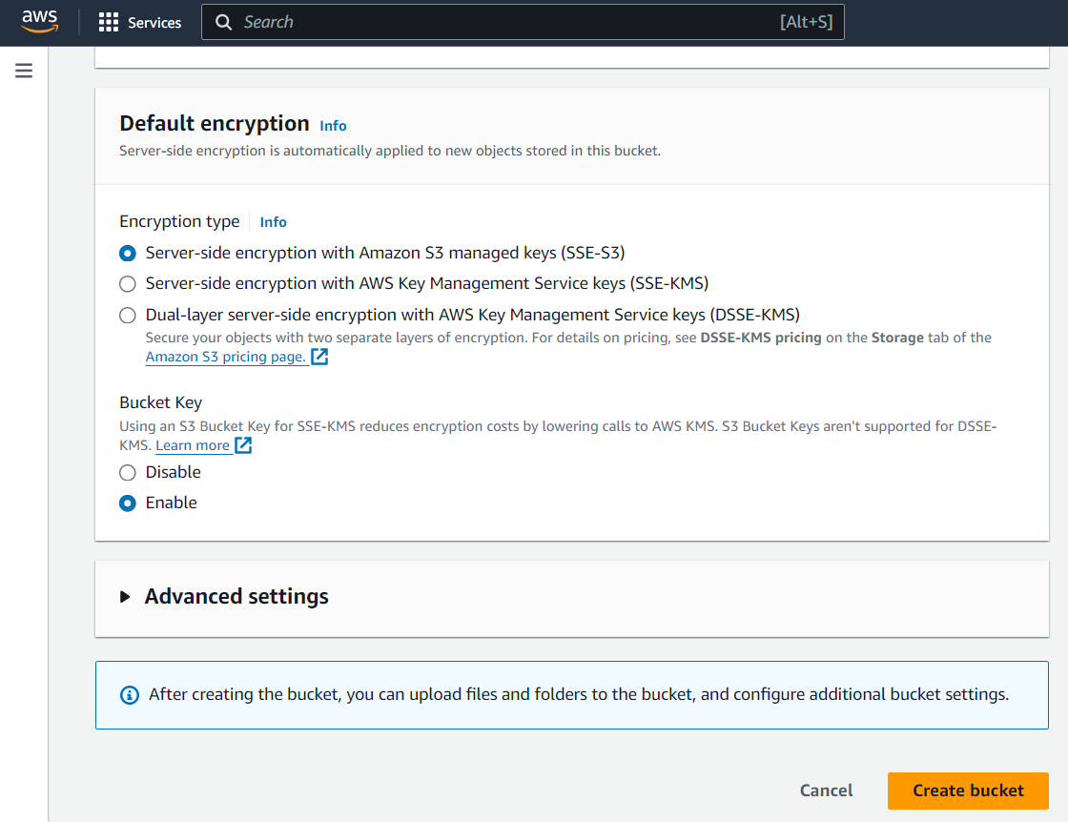

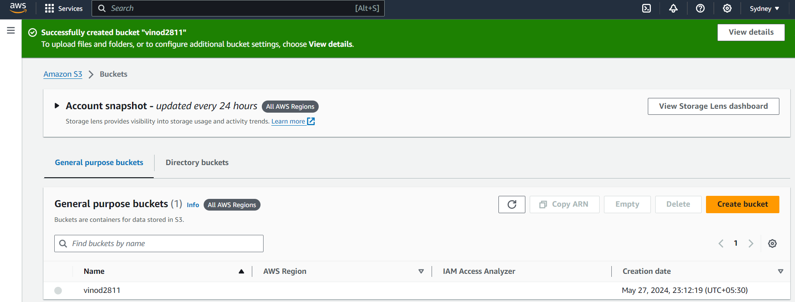

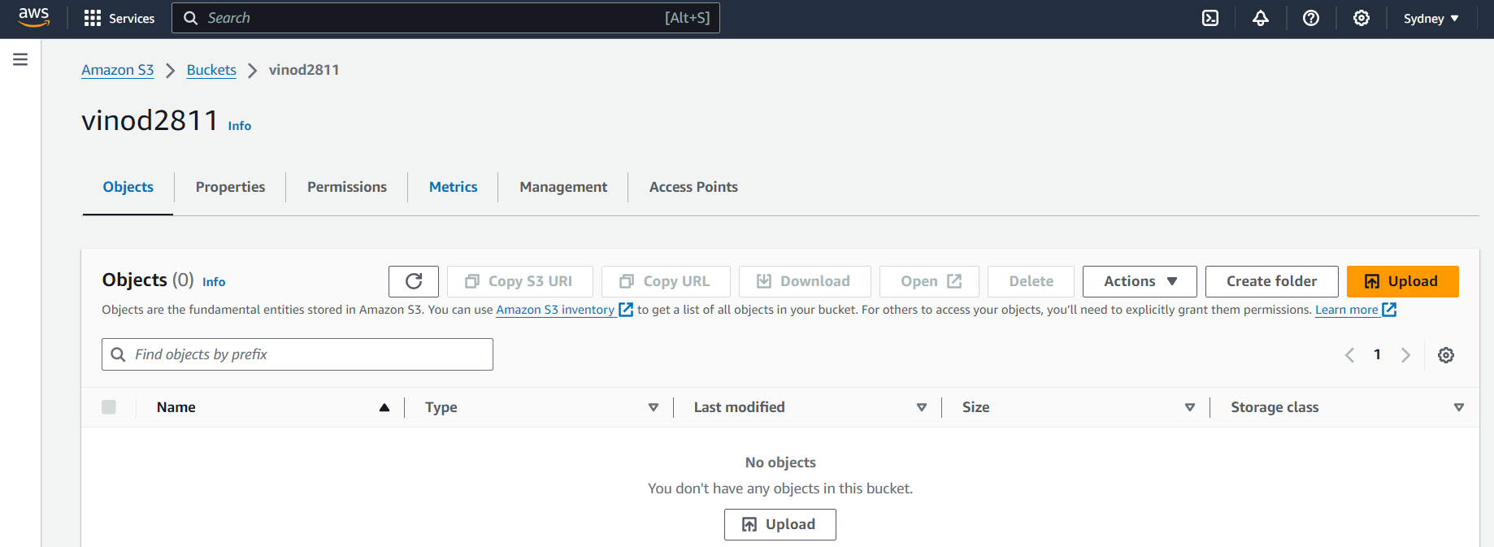

Let’s create destination bucket(for log monitor) by following similar steps used for source bucket

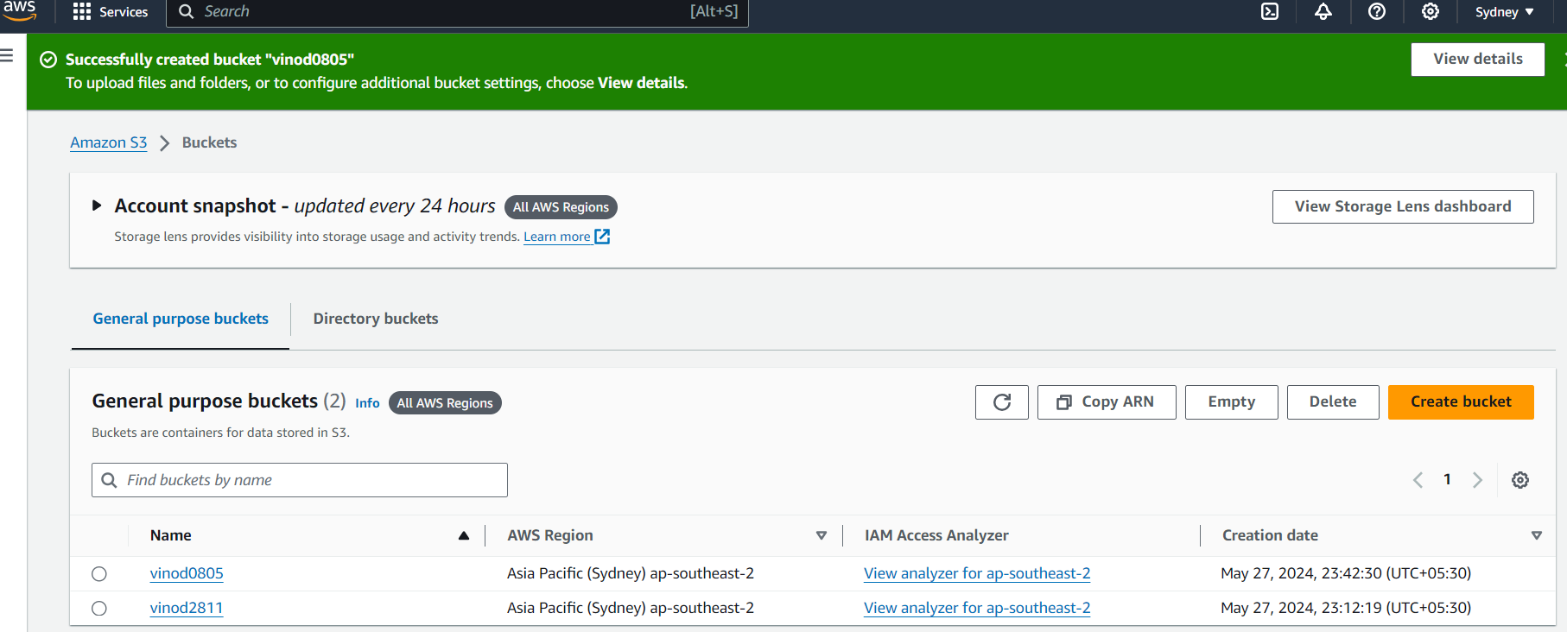

**Goto -> Properties section of source bucket vinod2811 -> To enable logs**

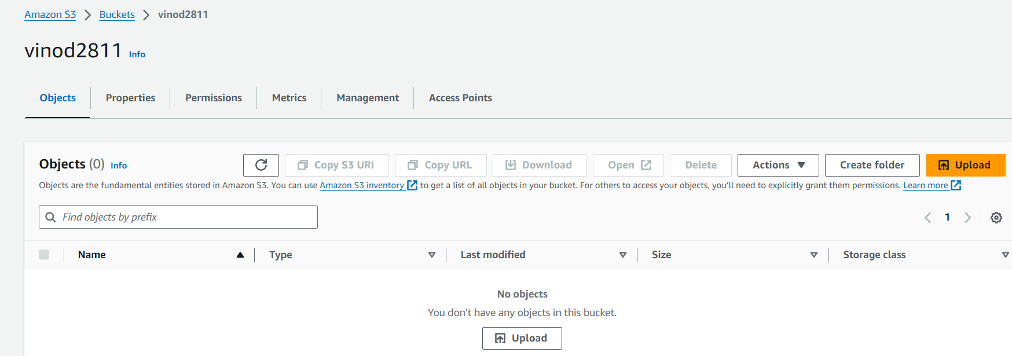

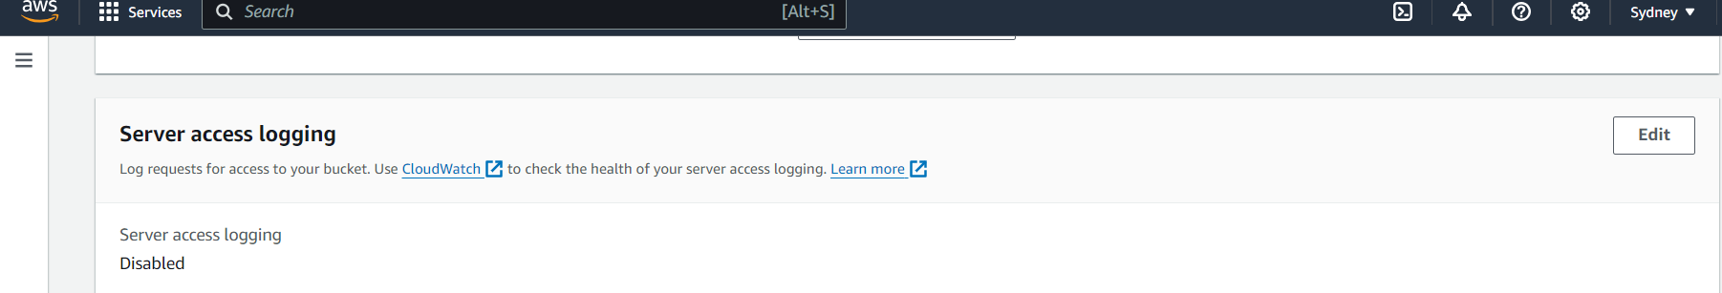

**Enable the server access logging and choose respective bucket for log redirection**

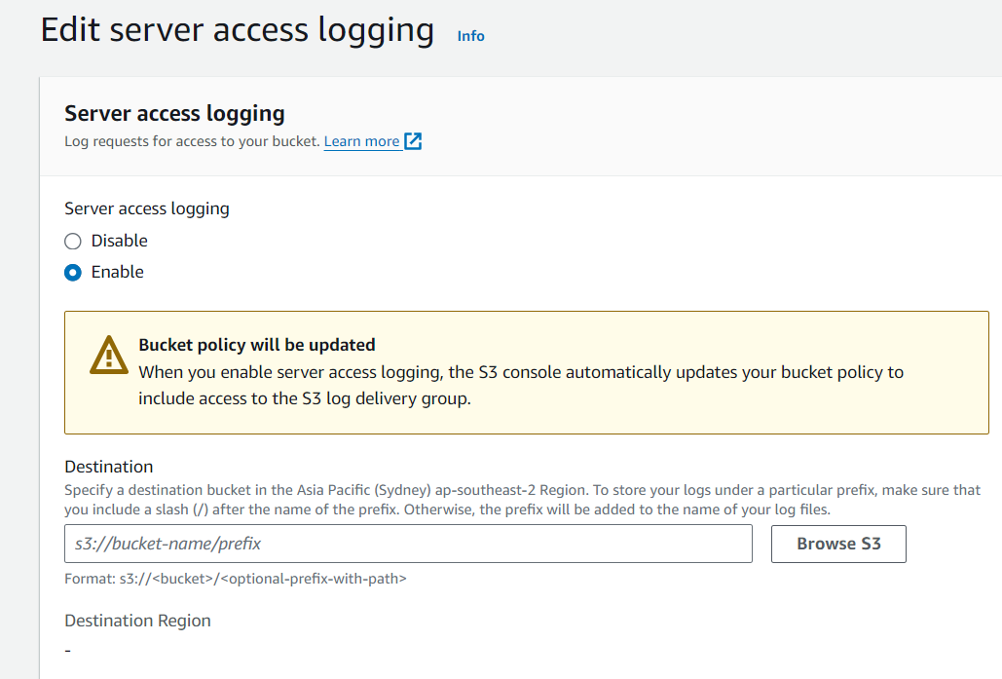

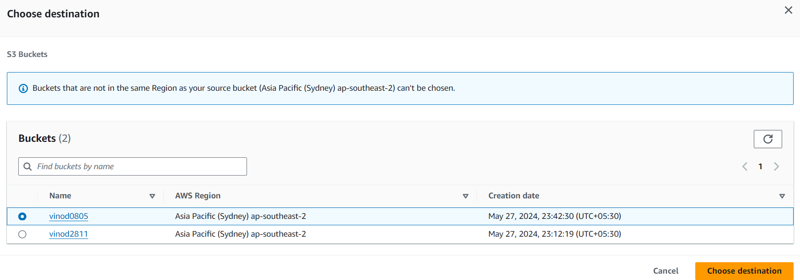

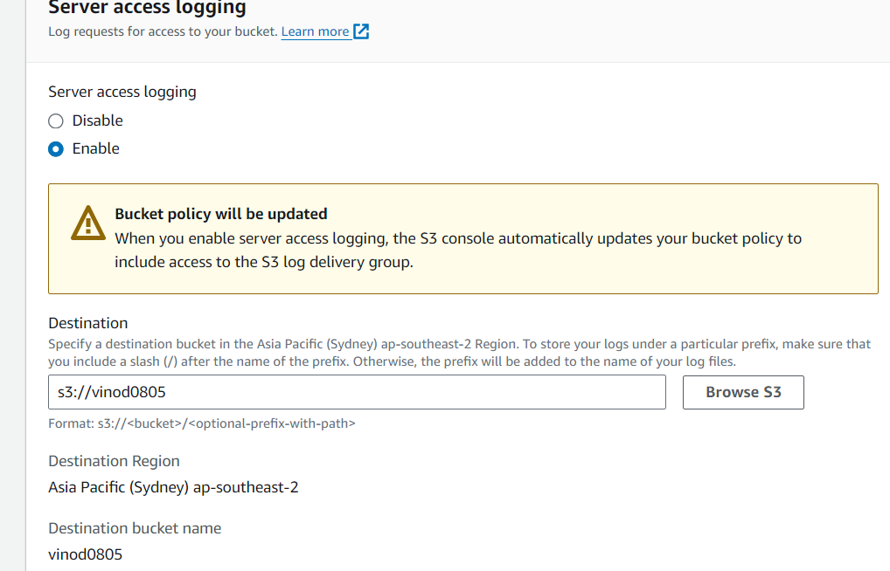

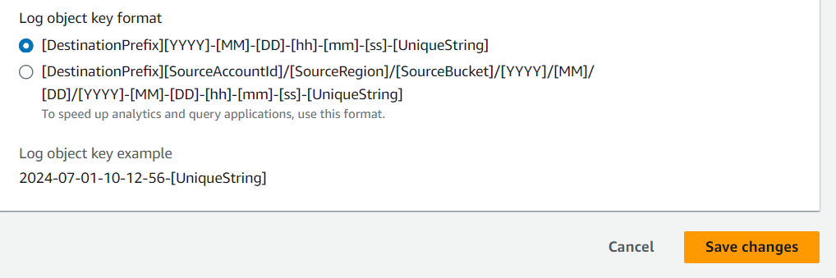

**Verify the sever access log enabling**

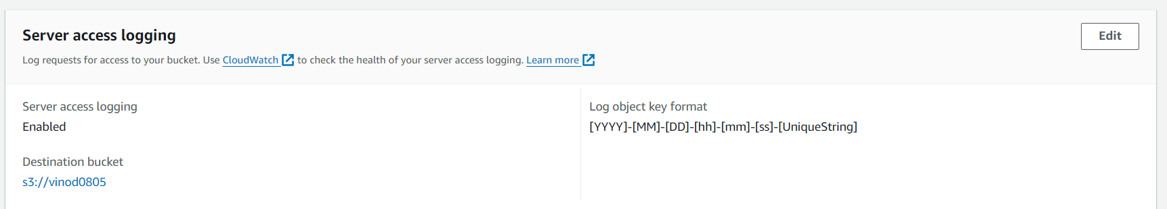

**Now we can try uploading some files to the source bucket ( vinod2811)**

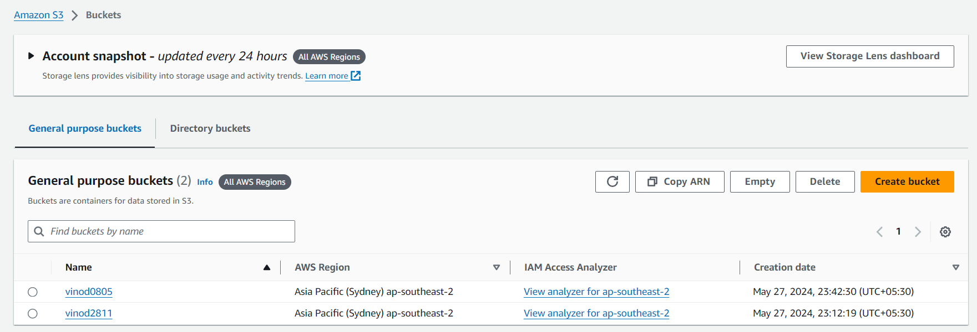

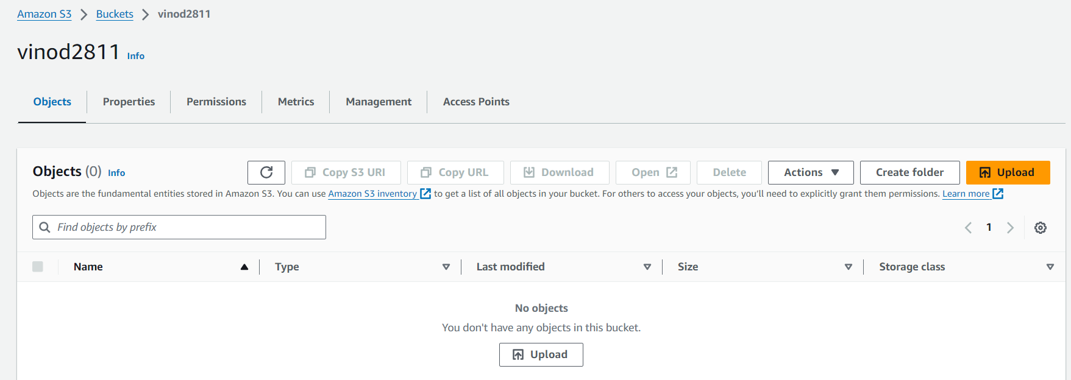

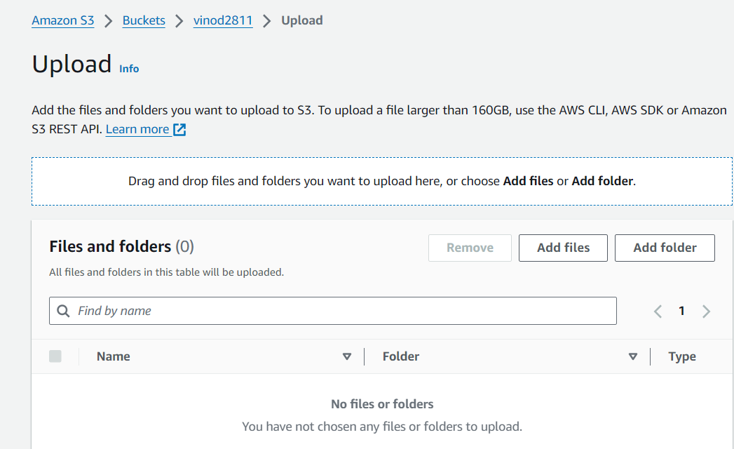

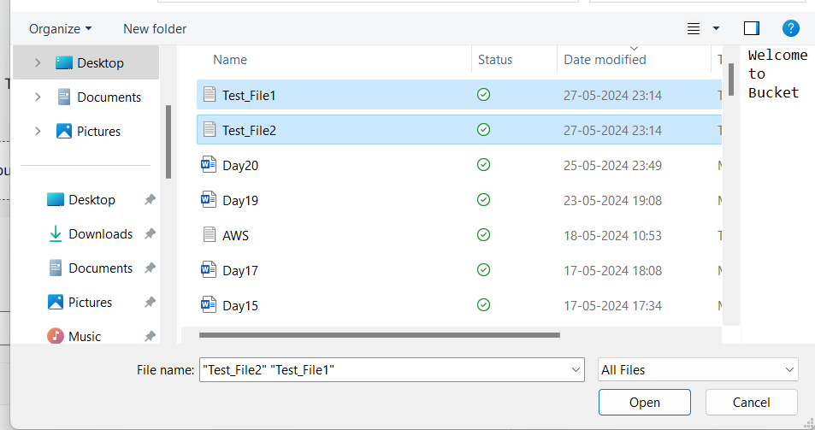

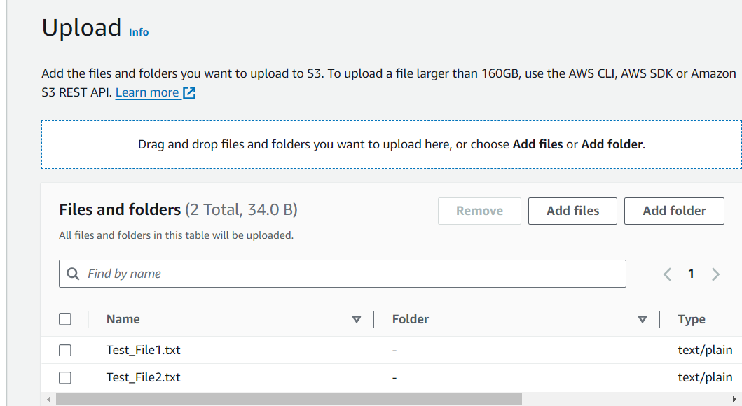

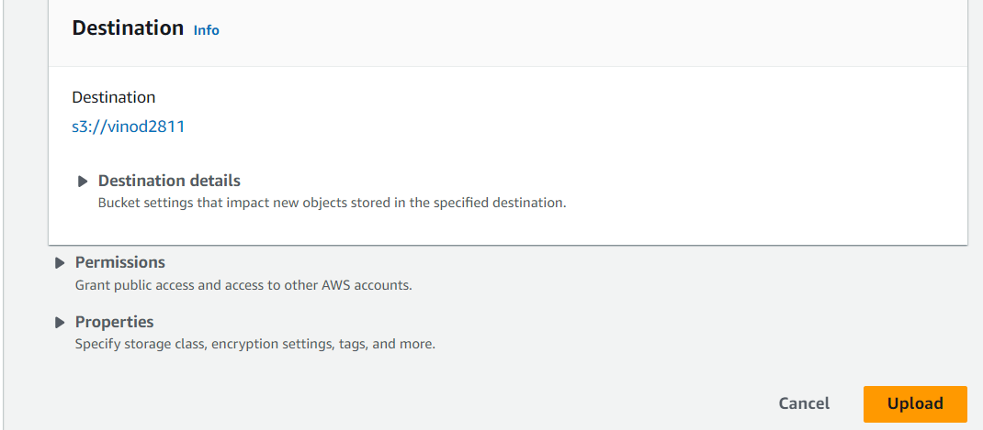

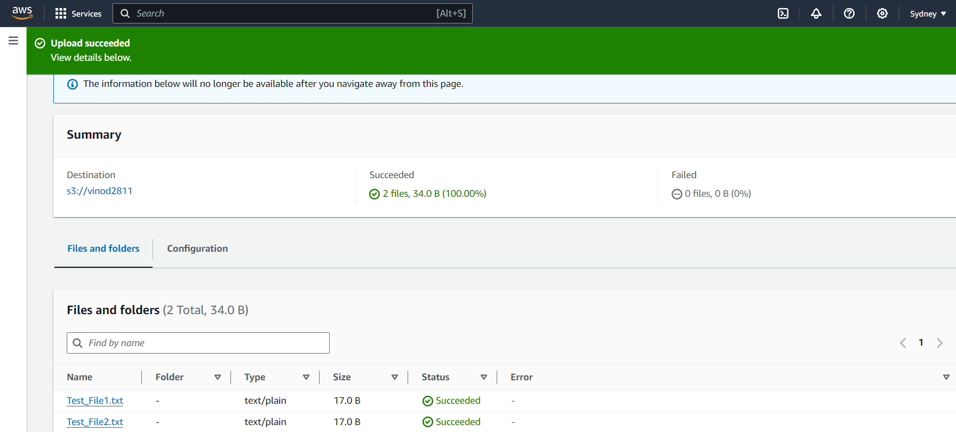

**Files uploaded :**

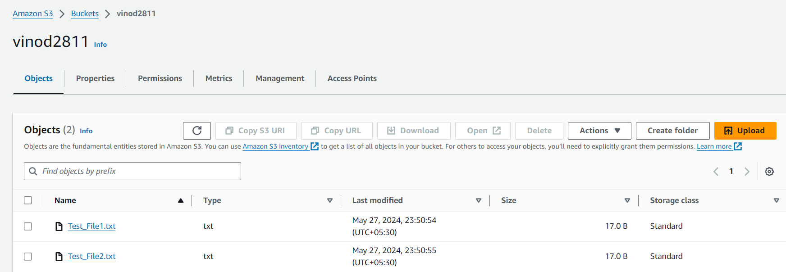

**Logs Verification:**

We can view the server logs for the uploaded files on below destination path ( vinod0805)

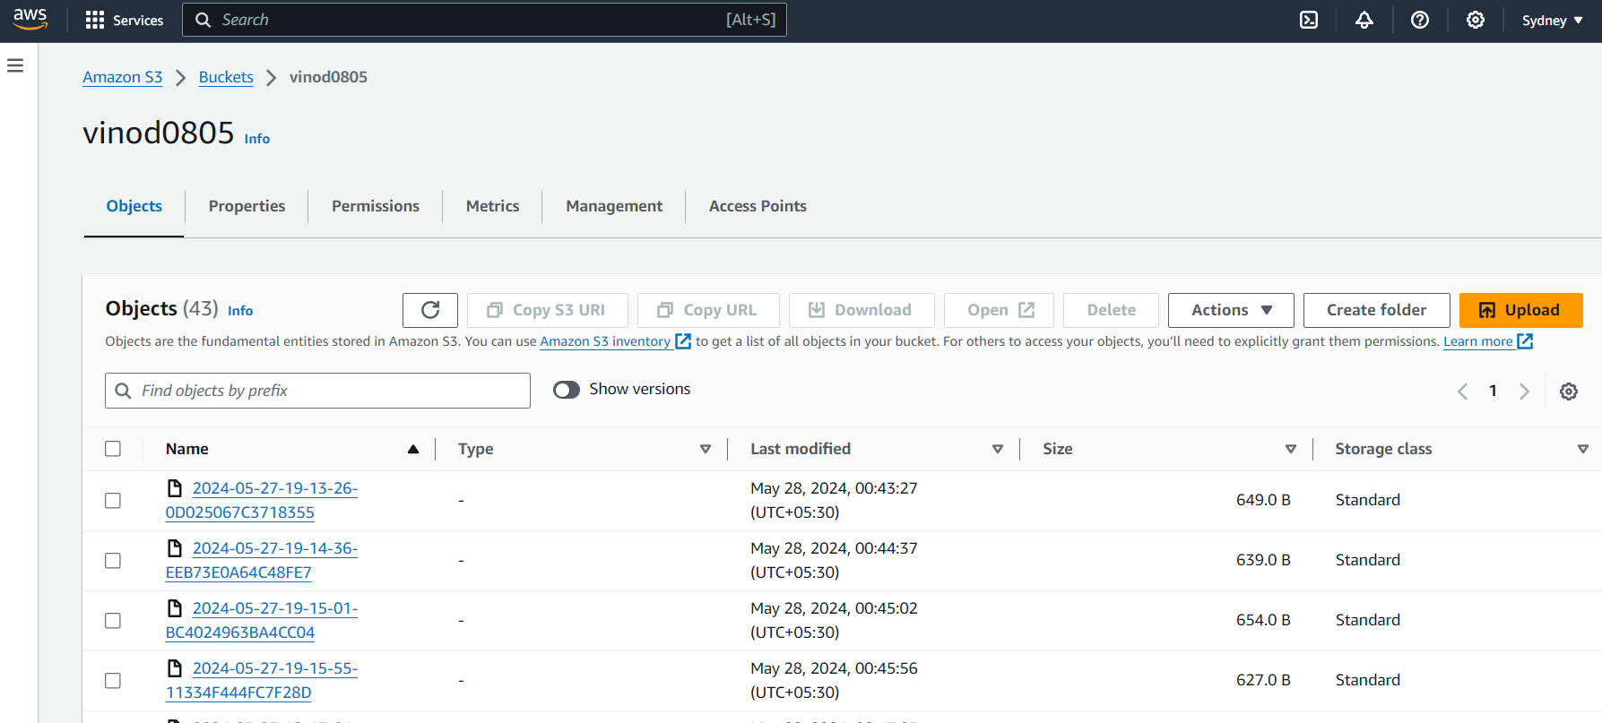

Hence files are uploaded and logs are verified on S3 bucket accordingly

As a good practise of learning, post validation we can remove the buckets to avoid unwanted charges

**Note** : It’s not recommended to use same bucket for source and destination (for log capture) it could result in a small increase in your storage billing .Hence we used different one for logs

**2) Launch two EC2 instances**

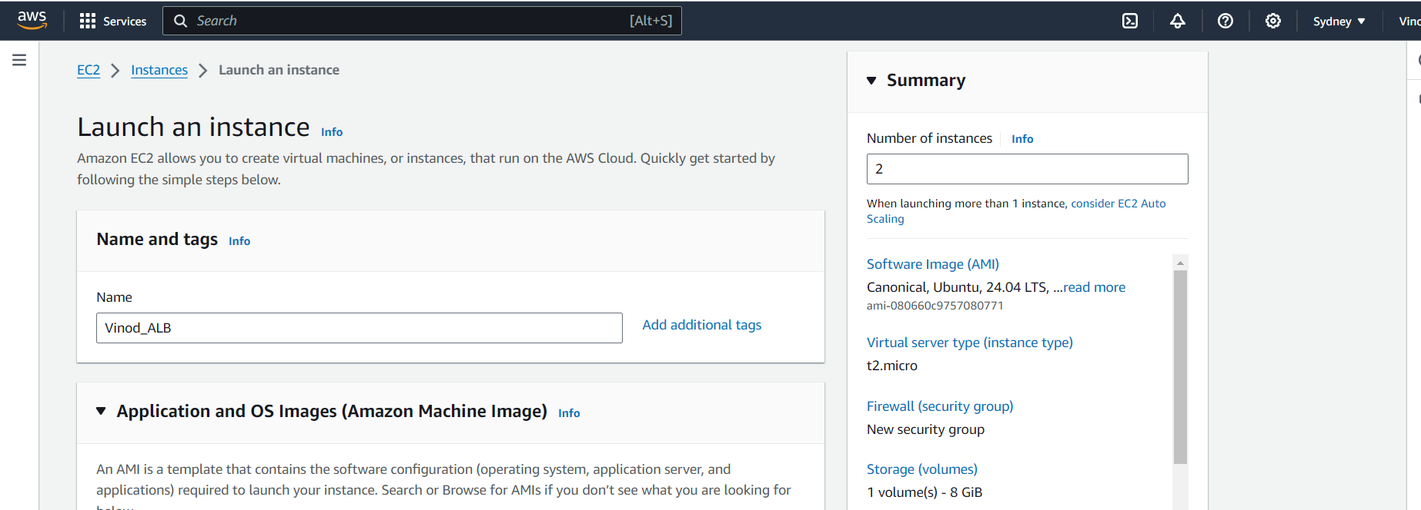

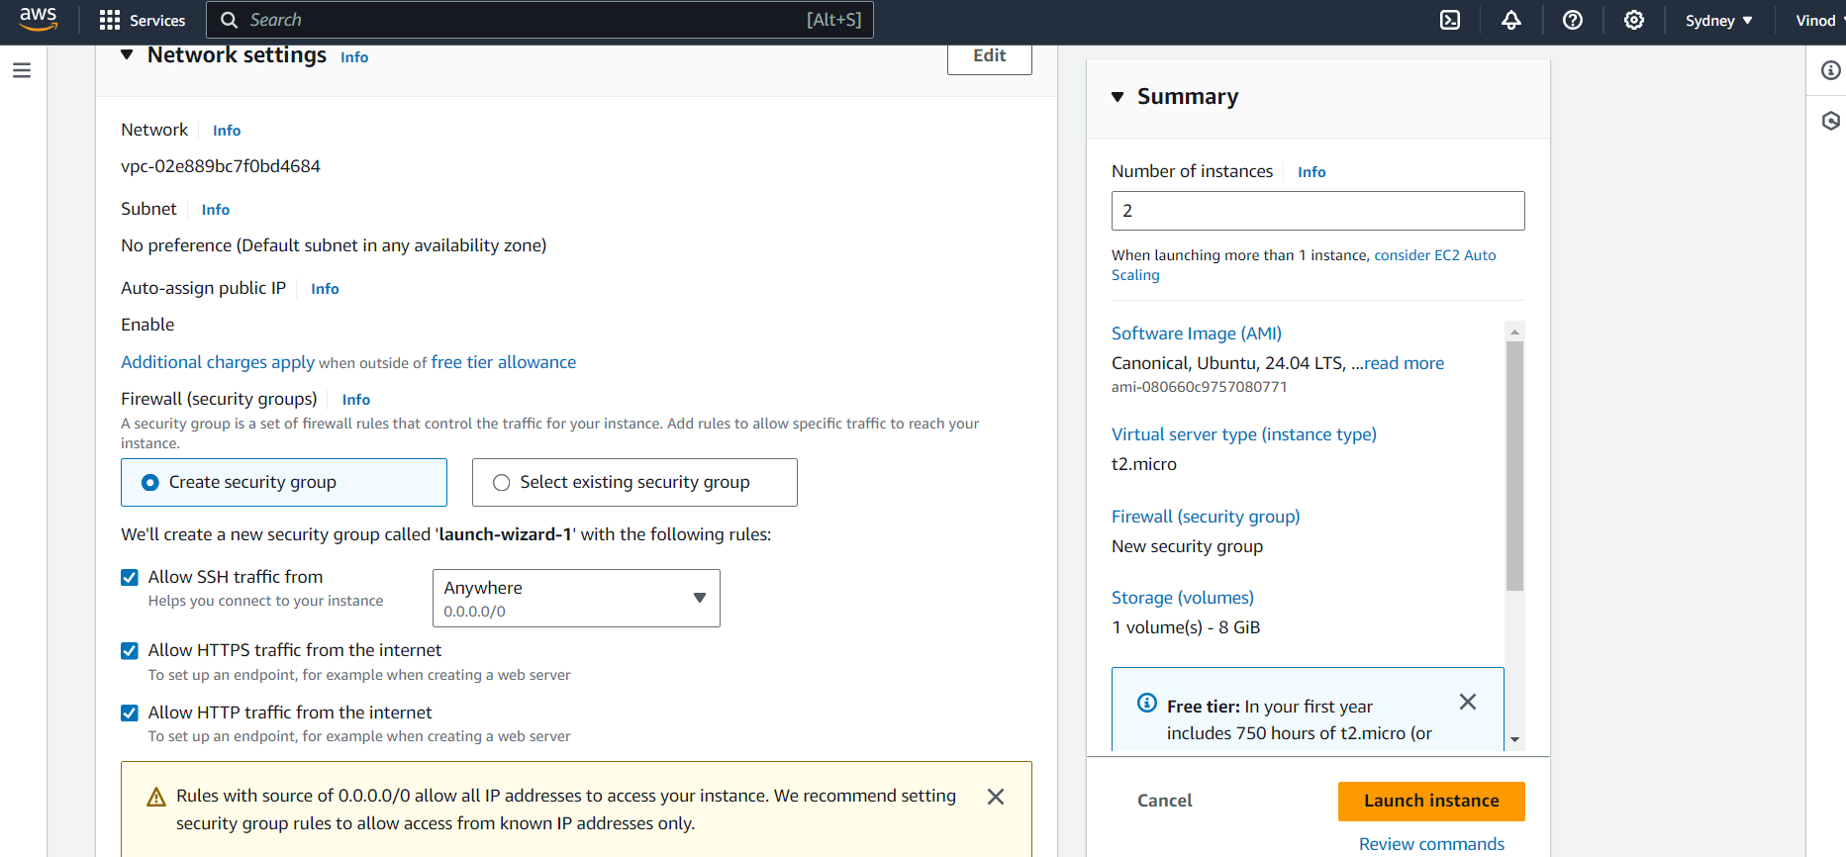

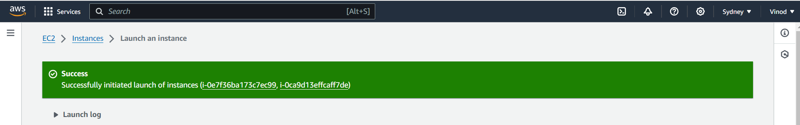

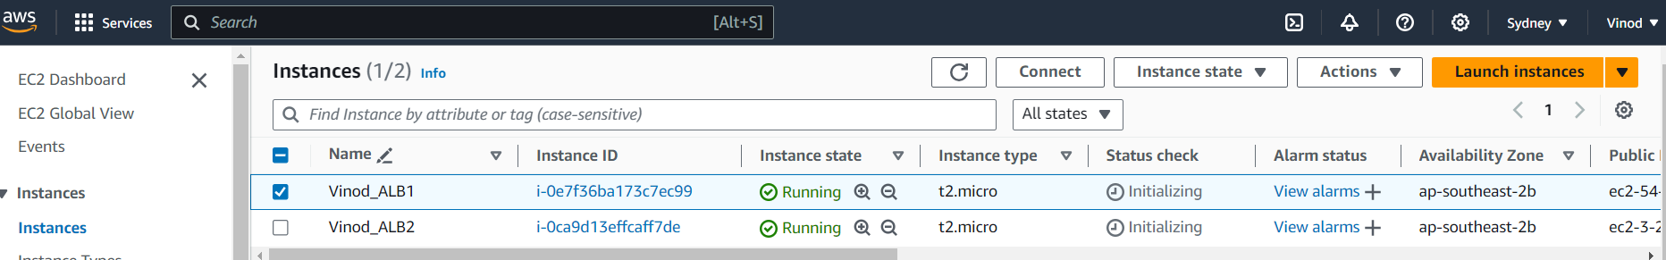

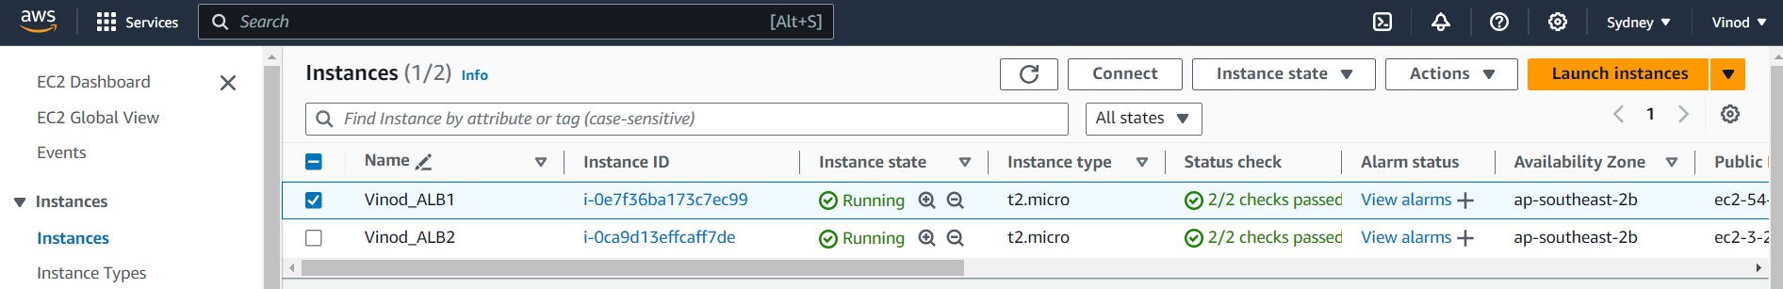

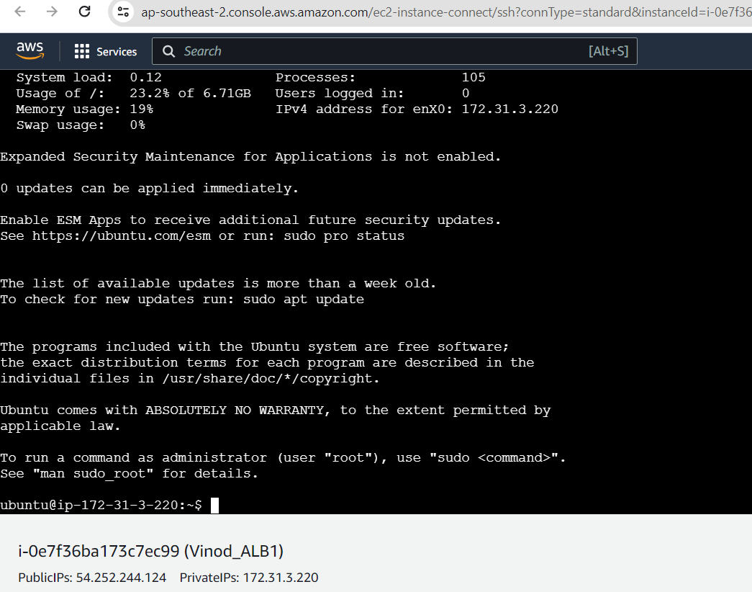

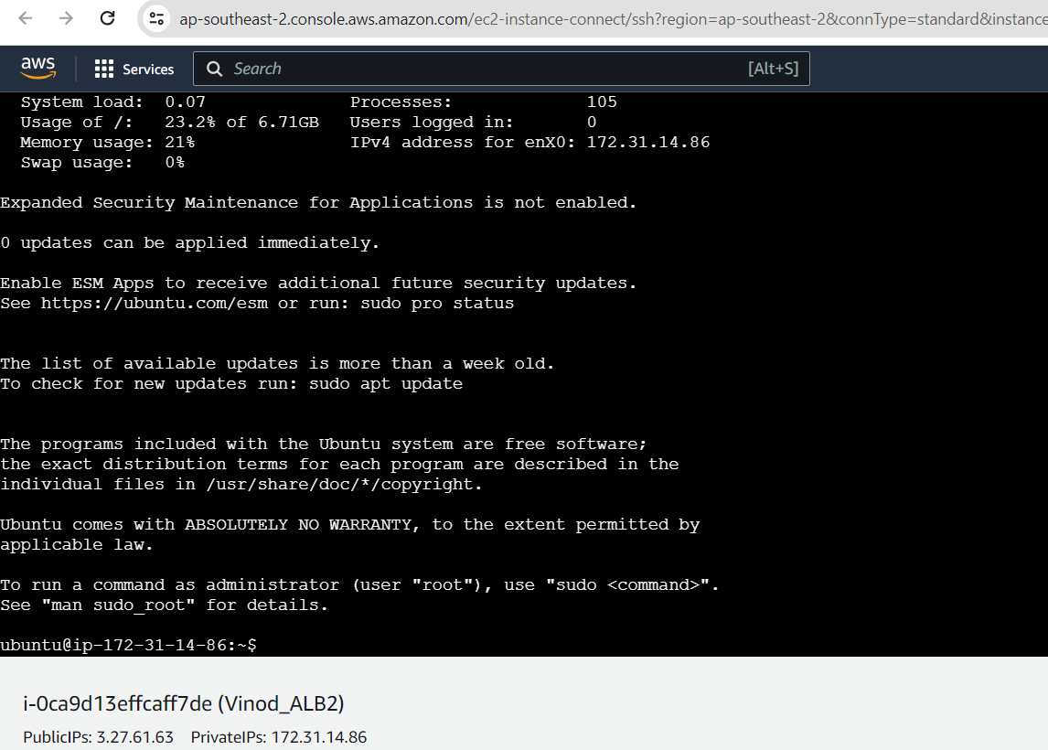

**Install apache on instance1**

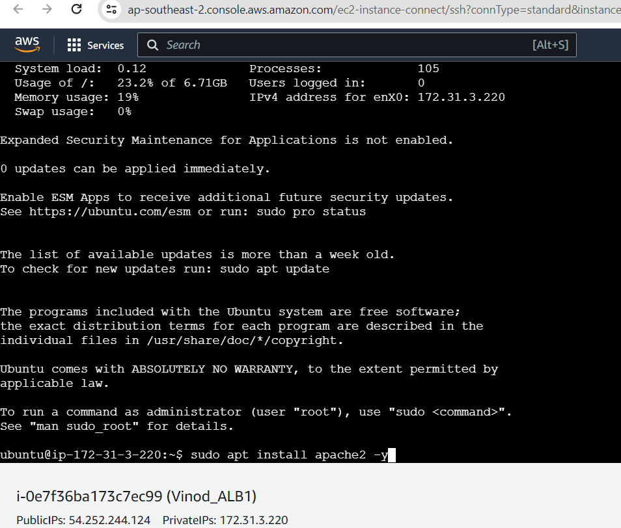

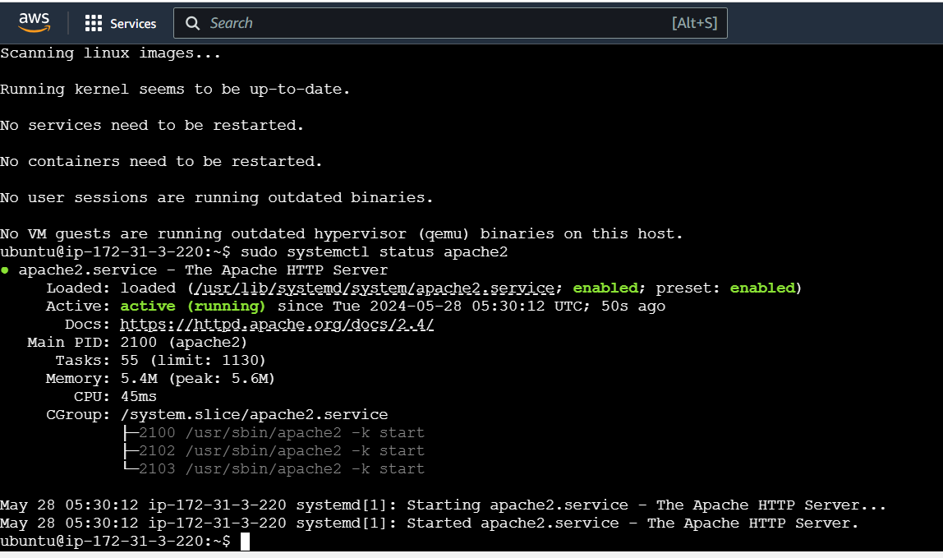

**Application running – Verified**

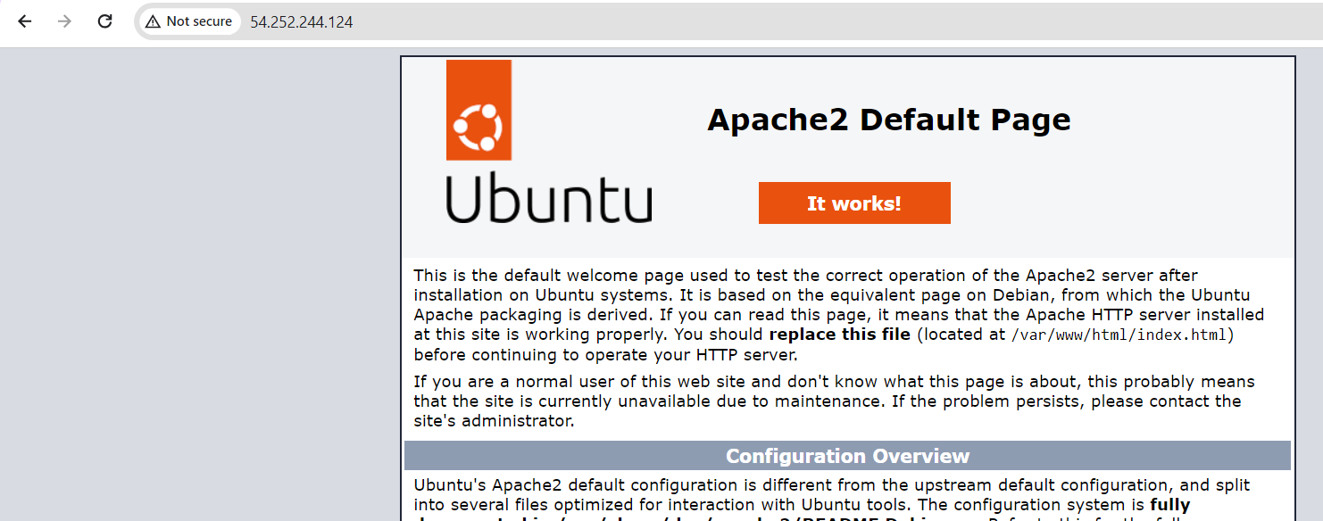

**2 ) Install nginx on instance 2**

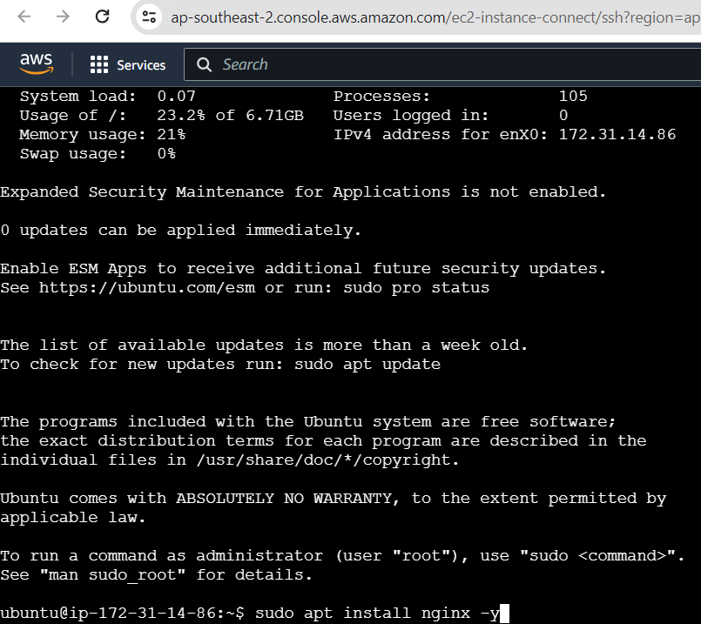

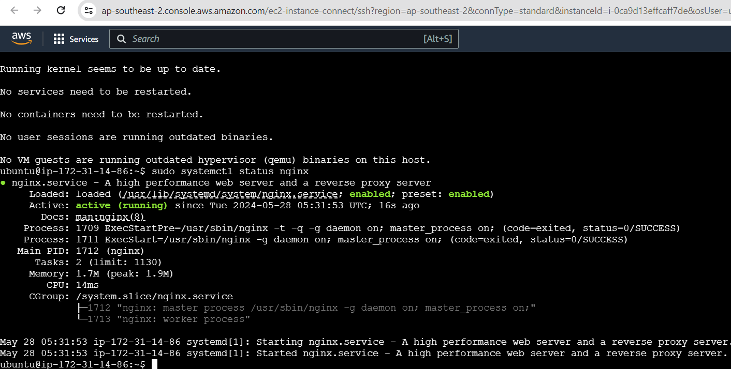

**Application running - Verified**

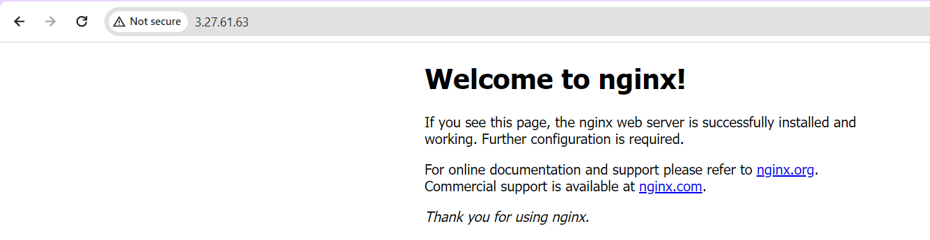

**Create Target Group :**

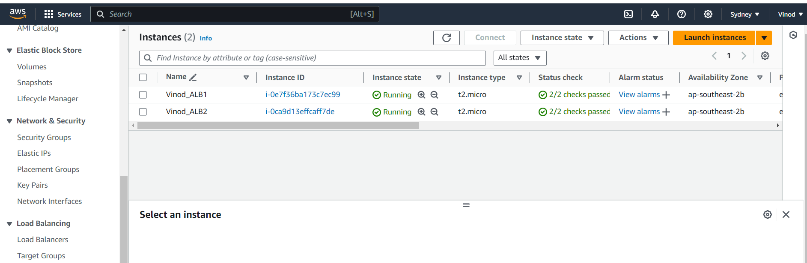

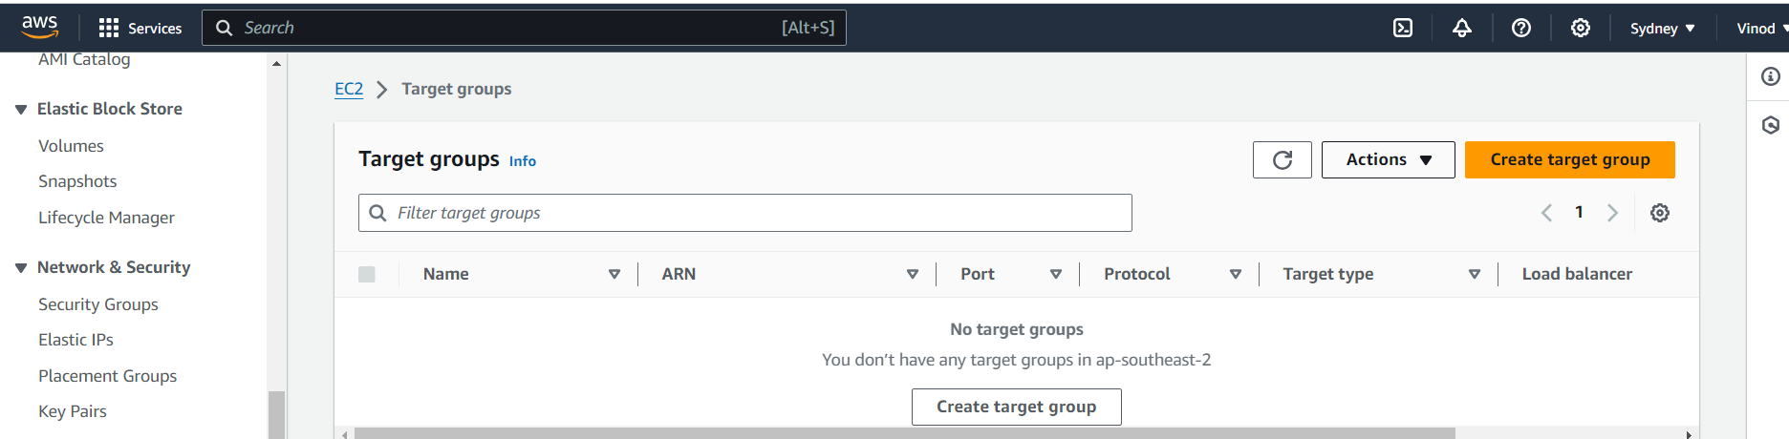

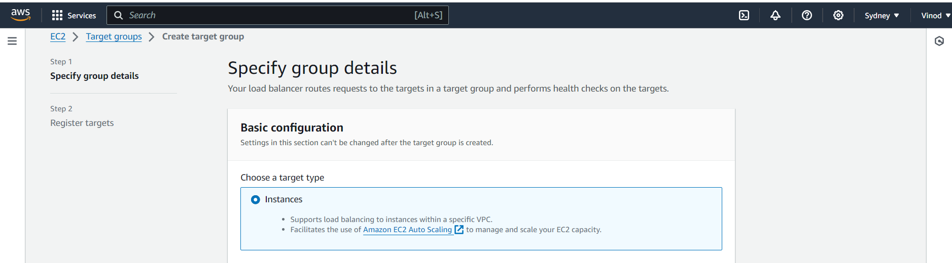

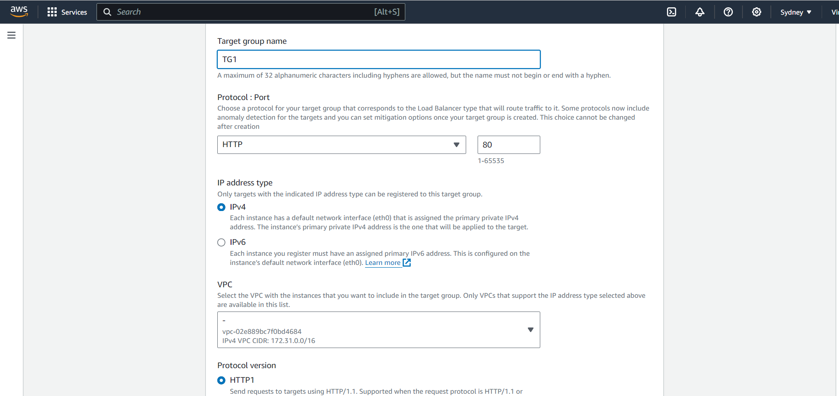

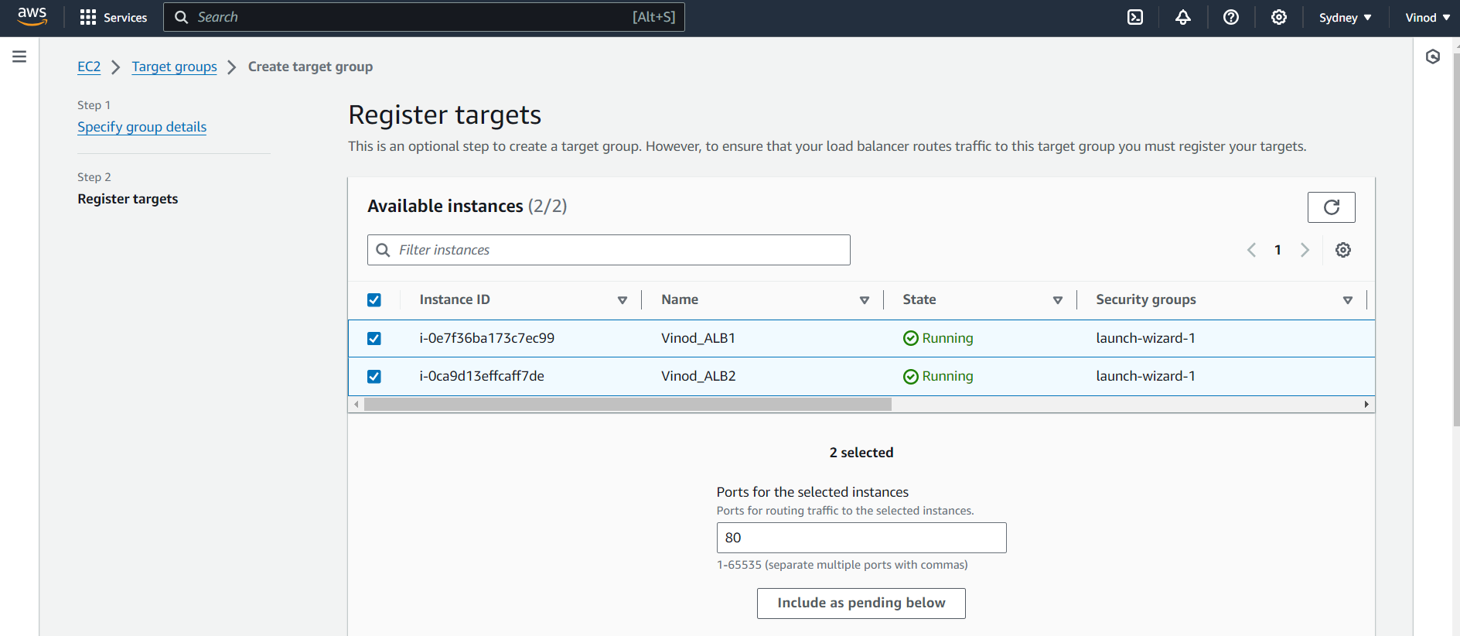

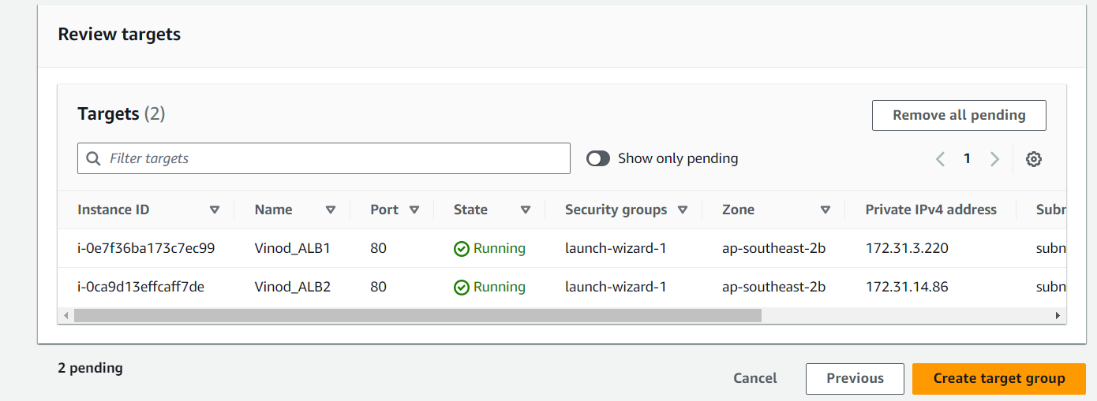

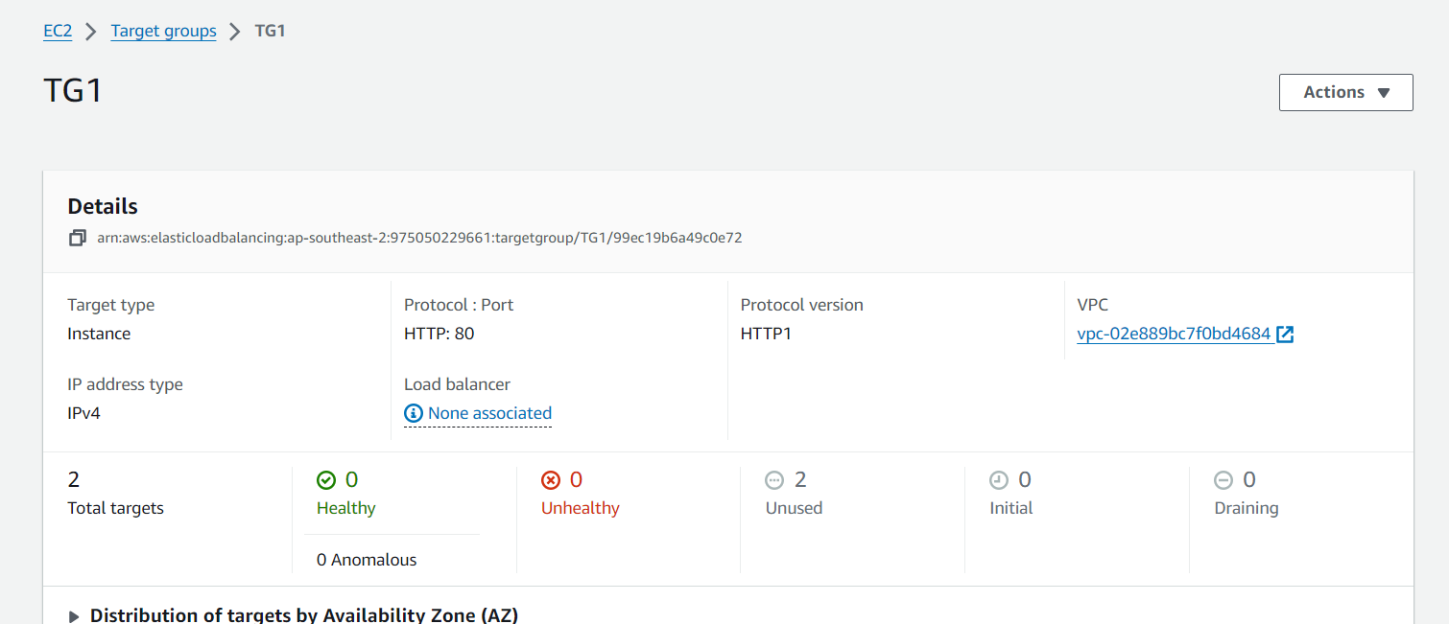

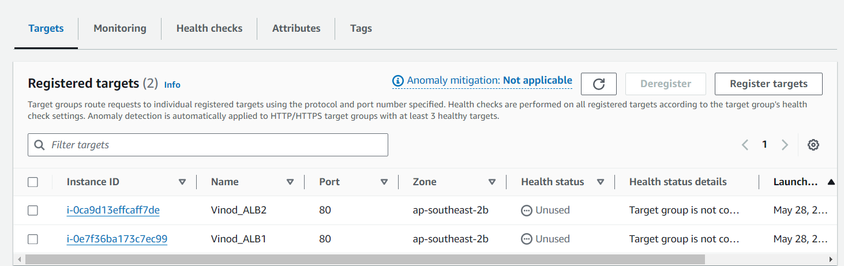

**Create Load Balancer:**

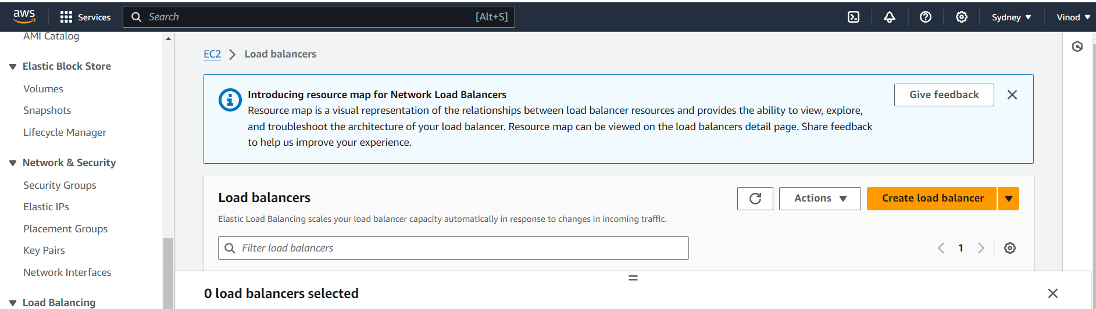

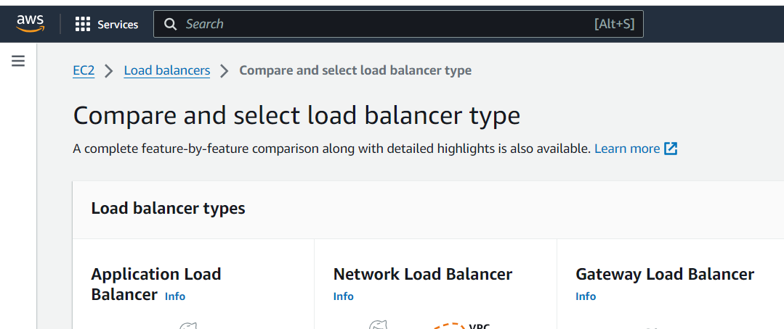

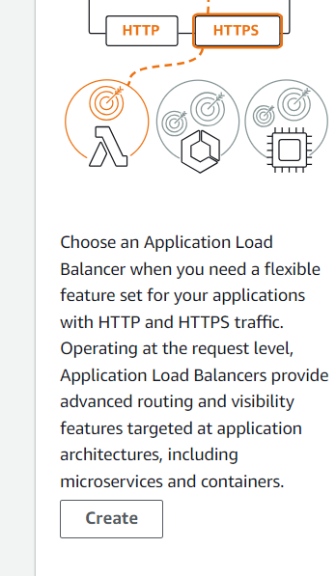

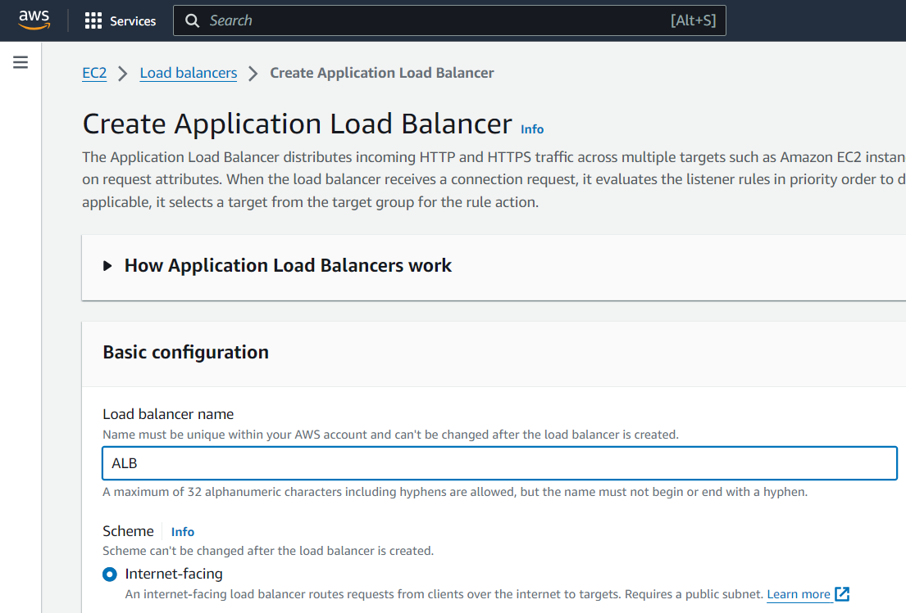

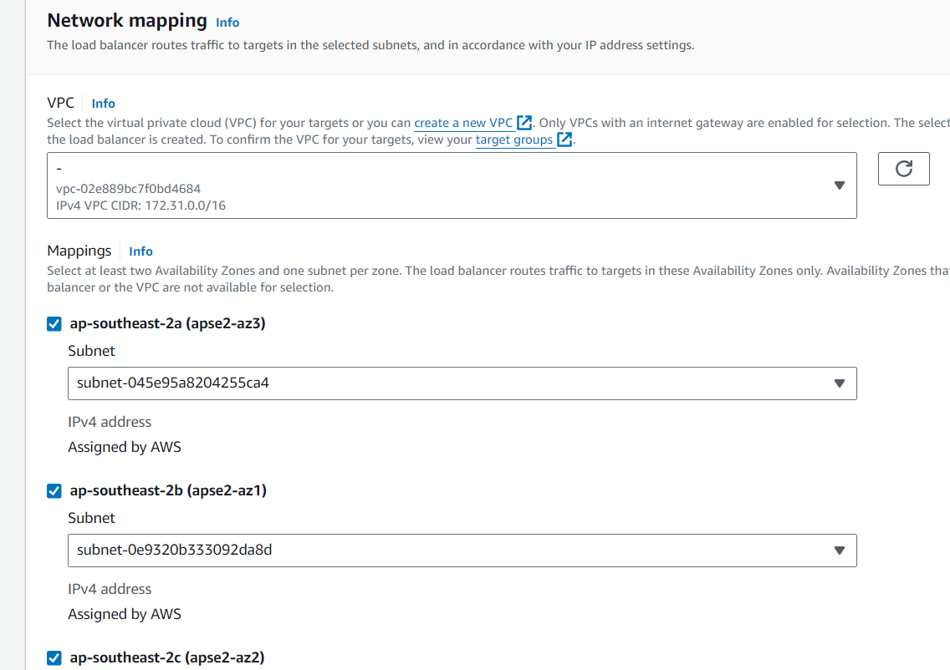

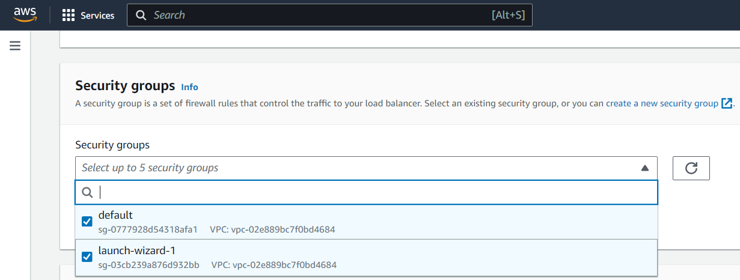

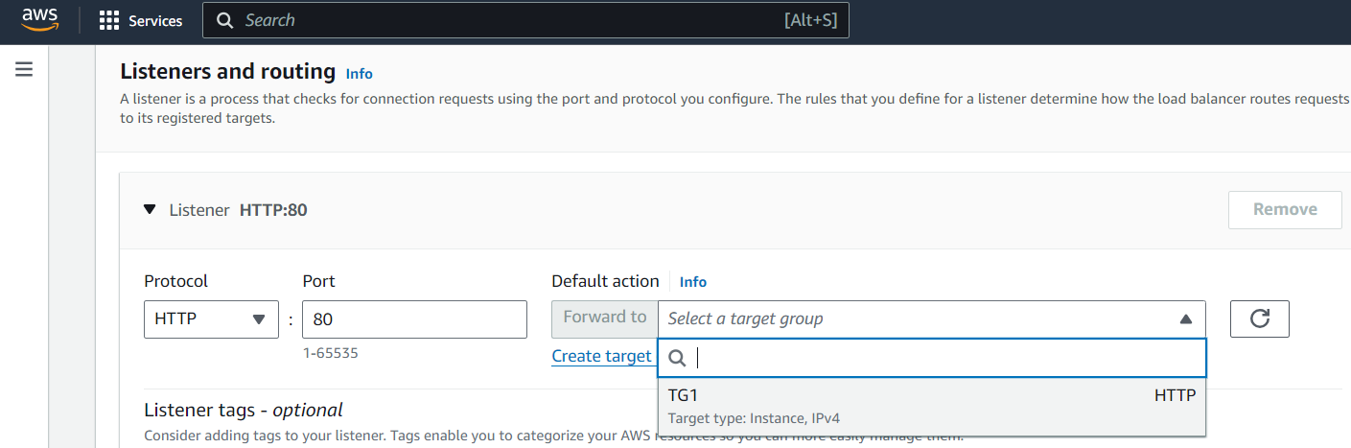

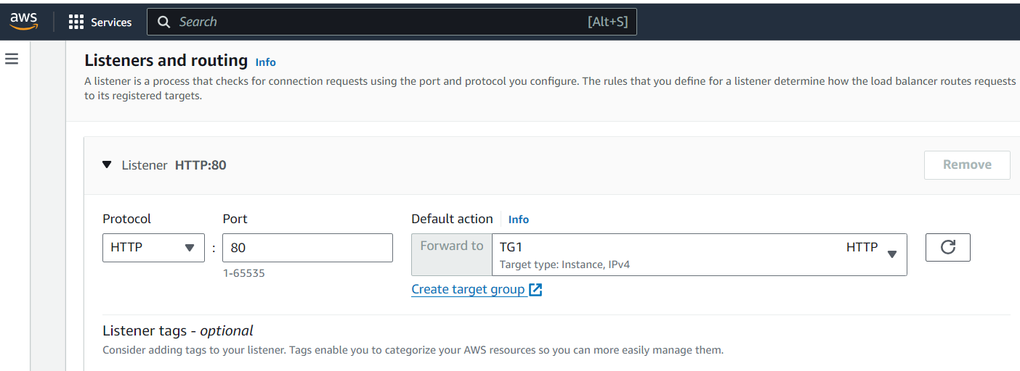

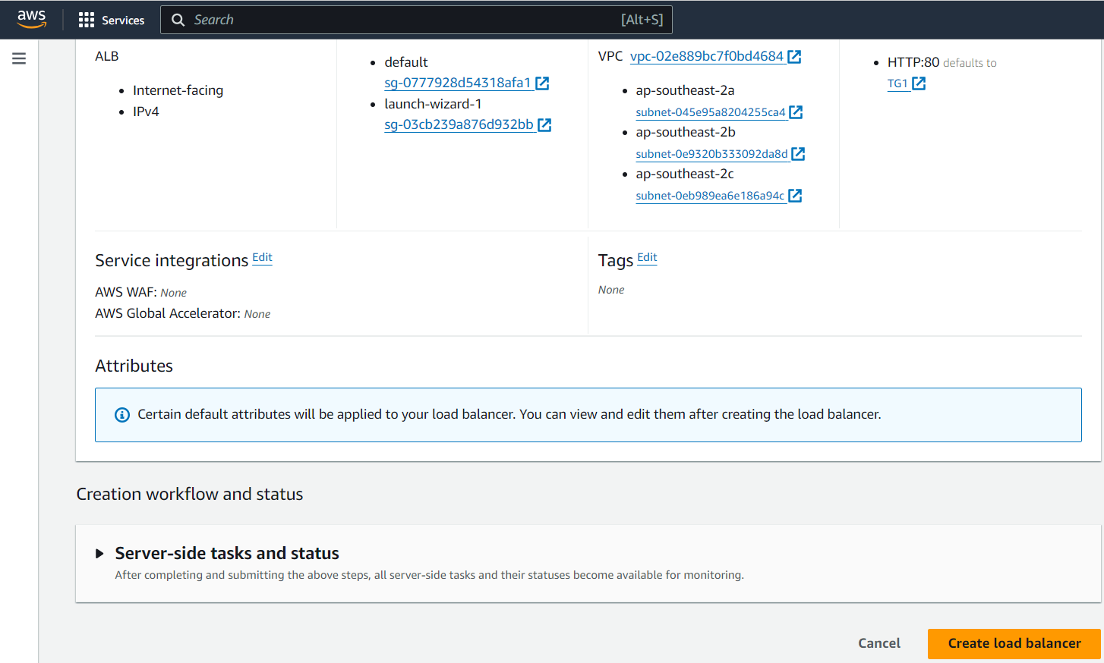

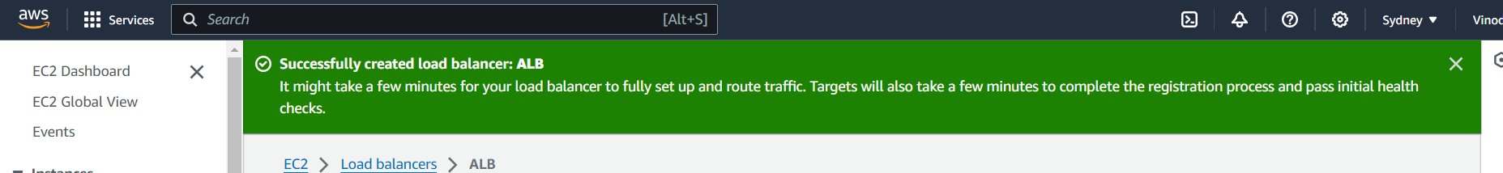

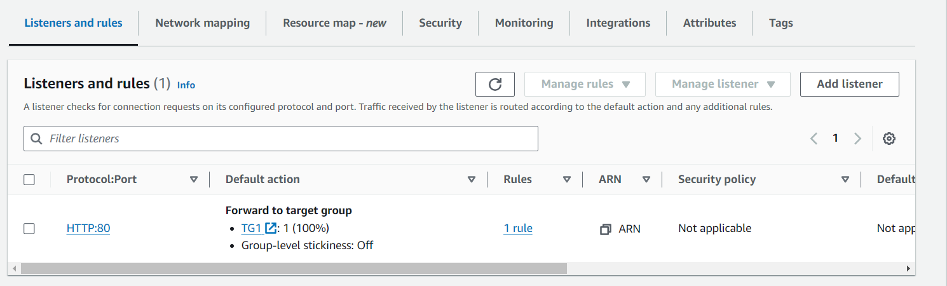

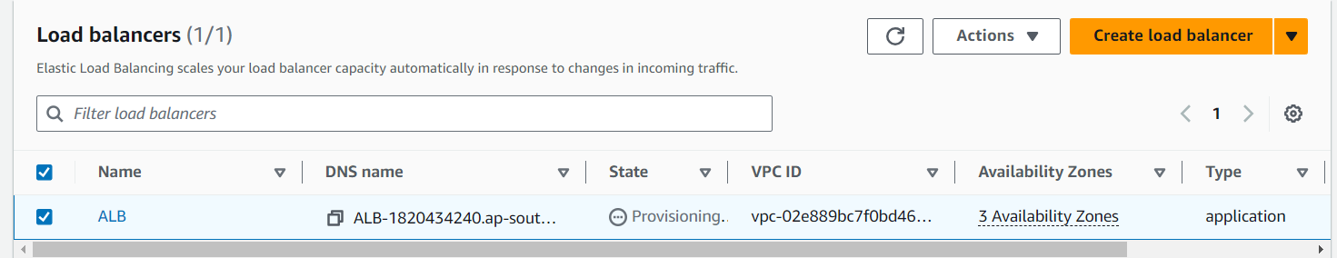

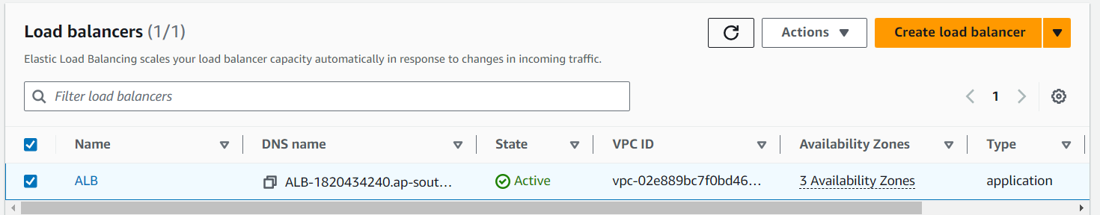

**Validating the Target group – Health check status**

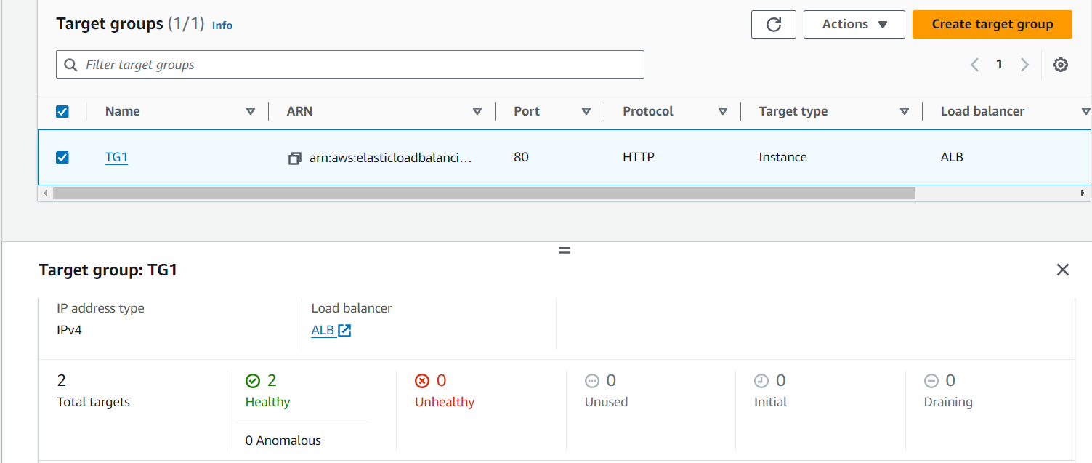

**Load balancer - Common DNS**

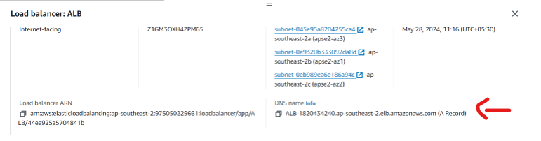

Now we can access both instance (application) by using common load balance link (DNS)

<http://alb-1820434240.ap-southeast-2.elb.amazonaws.com/>

Where the application gets loaded equally between two instances on each refresh or access

**Instance 1 ( Apache) :**

Before accessing the ALB DNS link

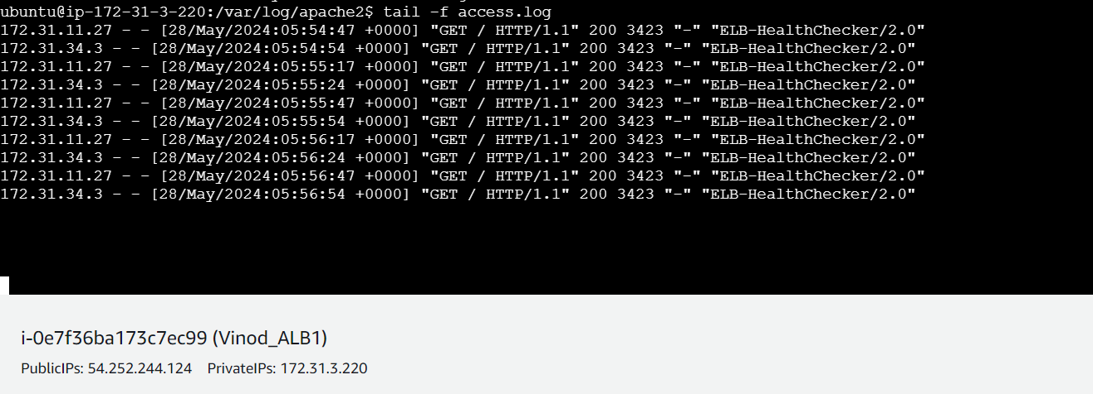

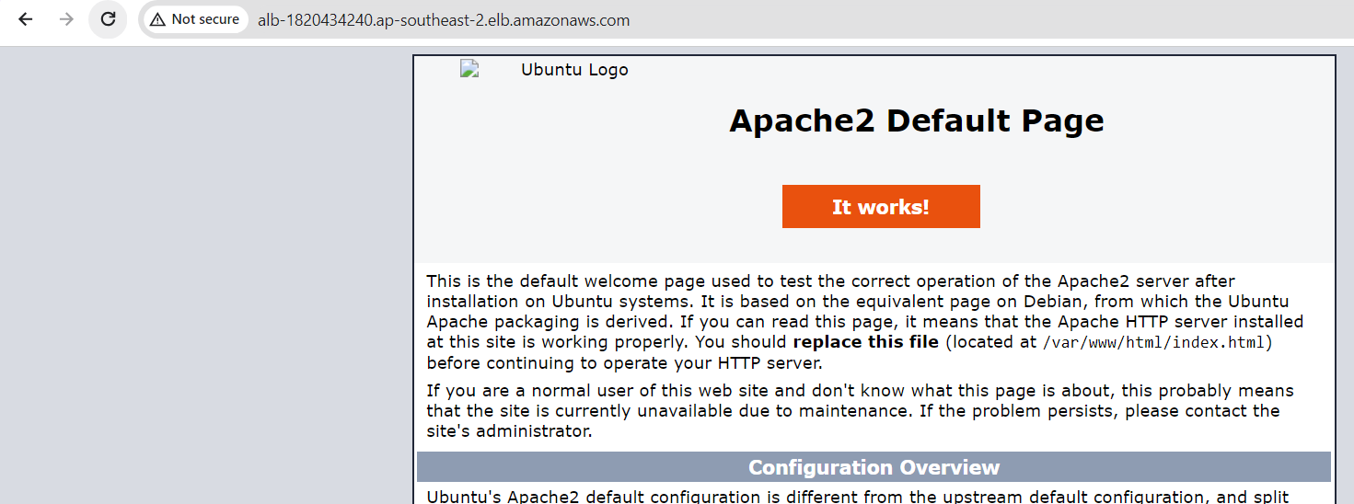

**Access entries has been captured in the Apache log**

After accessing the ALB DNS link

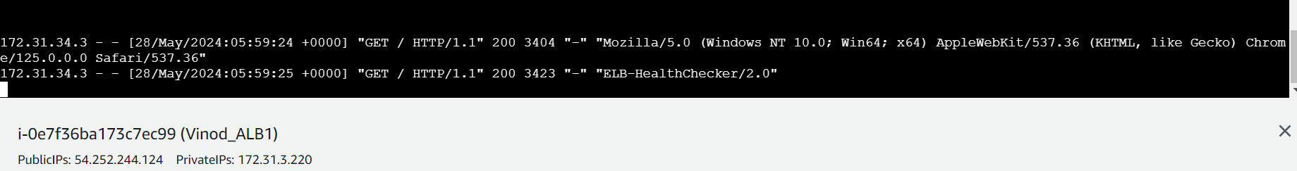

**Instance 2 ( Nginx ) :**

Before accessing the ALB DNS link

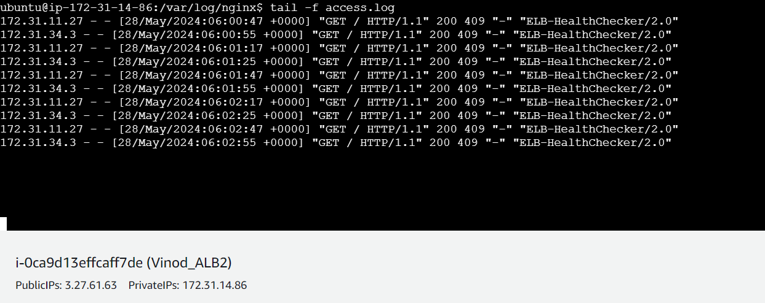

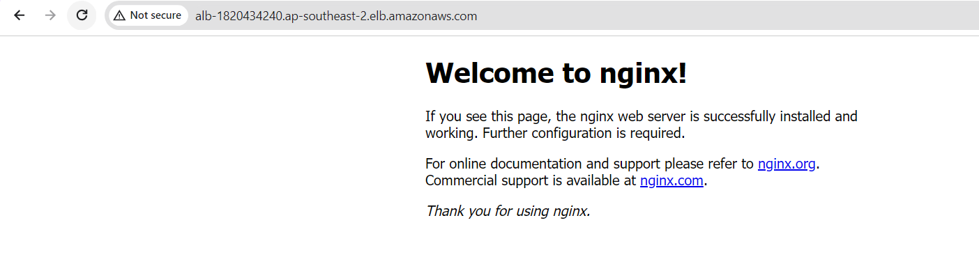

**Access entries has been captured the Nginx logs:**

After access

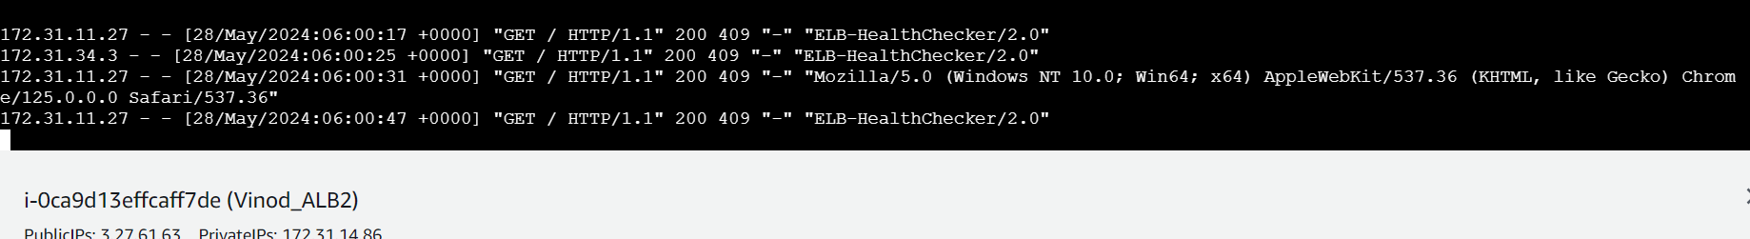

Hence we have successfully launched the EC2 Instances and the output traffic has been redirected via ALB DNS ” <http://alb-1820434240.ap-southeast-2.elb.amazonaws.com/>”